|  |  |  |  |  |  |  |  |  |
| --- | --- | --- | --- | --- | --- | --- | --- | --- |
| |  | | --- | | Denon Integrated Amplifier PMA-1600NE | | **https://audiohoanghai.com/media/product/7271_pma1600ne_2.jpg** |  |  |  |  |  | | --- | --- | --- | --- | | https://audiohoanghai.com/media/product/7271-pma1600ne_1.jpg | https://audiohoanghai.com/media/product/7271-pma1600ne.jpg | https://audiohoanghai.com/media/product/7271_dcd1600ne_e2.jpg |  | |  | **Specifications:**  **Output Power 8 Ohm (20 Hz - 20 kHz, THD 0.07%):** 70 W  **Output power 4 Ohm (1 kHz, THD 0.7%):** 140 W  **Total harmonic distortion:** 0.01%  **Input sensitivity:** MM 2.5 mV / 47 kohm  **Input sensitivity:** MC 200 µV / 100 ohm  **Signal-to-noise ratio:** MM / MC 89 dB / 74 dB  **Input sensitivity:** High level 125 mV / 47 kohms  **Signal-to-noise ratio:** High level 108dB  **Weight:** 17.6 kg  **Price: 1.199$** |

**Overview:**

Denon Integrated Amplifier PMA-1600NE | Audio FOTOLAB

Denon is one of the rare audio brands that actively develops Hi-Fi components, accumulating, refining and retransmitting Hi-Fi audio technologies.

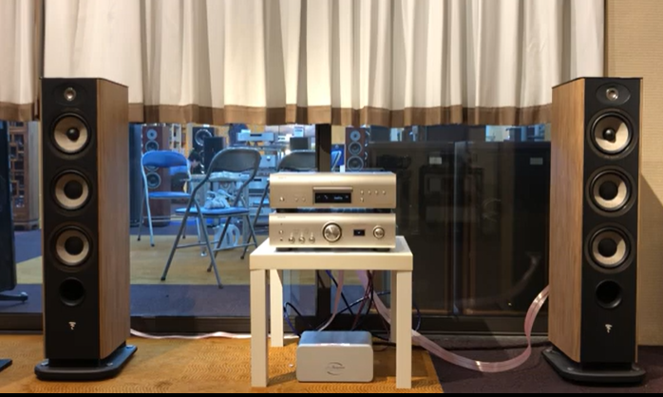

The performance of the PMA-1600NE far exceeds that of Denon's previous PMA-1500 series. With high quality, unique Denon technology and advanced connectivity, the PMA-1600NE is truly a masterpiece of audio technology.

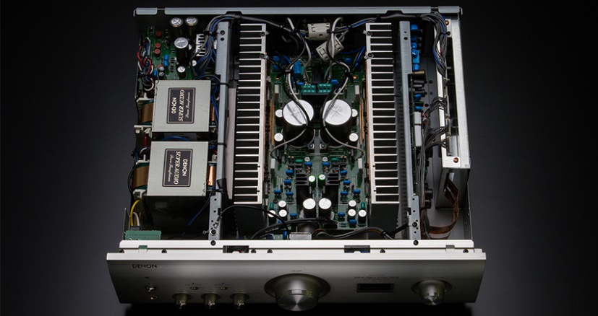

Thanks to the rear USB-B input and the high-quality D/A converter used, the PMA plays high-resolution files up to 384kHz/32bit and DSD up to 11.2MHz from a computer with quality. perfect sound.

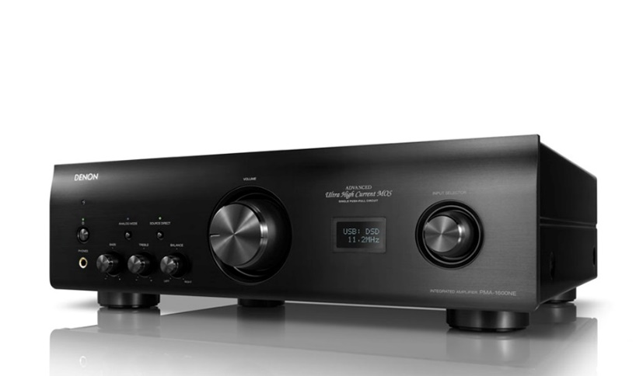

For the best performance from the inputs, the PMA-1600NE features an Analog Mode that allows turning off all unused sections such as the digital input circuit or low-noise display for noise-free audio reproduction. change.

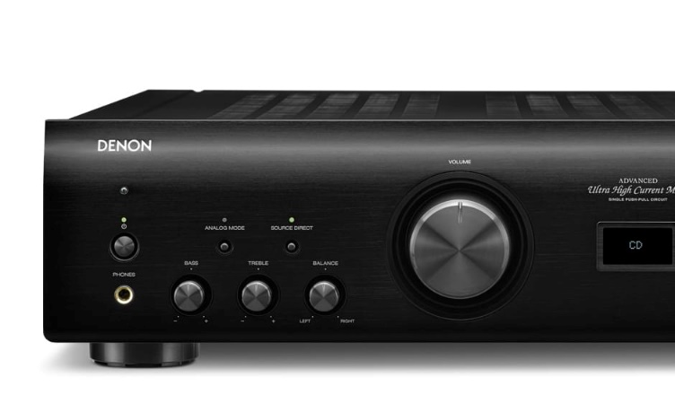

The amplifier features Advanced UHC (Ultra High Current)-MOS technology, which uses a minimal number of high-current amplifier components to balance the speaker's capabilities and provide improved sound quality.

The chassis of the PMA-1600NE is configured with six independent blocks containing the phono equalizer and input circuit, volume control circuit, USB-DAC circuit, amplifier circuit, power section and control section.

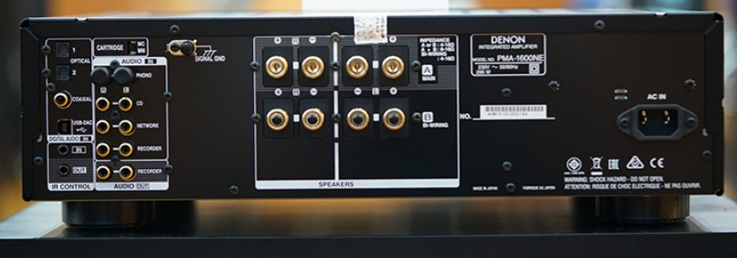

The PMA-1600NE comes with a remote control that can operate the DCD-1600NE and other Denon CD players.